TEMPLATE FOR AUTHORS OF YBL JOURNAL OF BUILT ENVIRONMENT

# Fiona First1, Simon Second2 and Thomas Third3

1Department of Mathematics, XY University, Budapest, Hungary

[f.first@xx.yy.zz](mailto:f.first@xx.yy.zz)

2Institute of Civil Engineering, XY University, Budapest, Hungary

[s.second@zzz.com](mailto:s.second@zzz.com)

3Institute of Architecture, XY University, Budapest, Hungary

[t.third@xx.yy.zz](mailto:t.third@xx.yy.zz)

***Keywords:***There may be up to five keywords (or short phrases) in 10 pt. Open Sans italics*.*

**Abstract:** The abstract must not exceed 300 words in length in 10 pt. Open Sans. The text must be fully justified. This is the abstract of the article. This is the abstract of the article. This is the abstract of the article. This is the abstract of the article. This is the abstract of the article. This is the abstract of the article. This is the abstract of the article. This is the abstract of the article. This is the abstract of the article. This is the abstract of the article. This is the abstract of the article. This is the abstract of the article. This is the abstract of the article. This is the abstract of the article. This is the abstract of the article. This is the abstract of the article. This is the abstract of the article. This is the abstract of the article. This is the abstract of the article. This is the abstract of the article. This is the abstract of the article. This is the abstract of the article. This is the abstract of the article. This is the abstract of the article. This is the abstract of the article. This is the abstract of the article. This is the abstract of the article. This is the abstract of the article. This is the abstract of the article. This is the abstract of the article. This is the abstract of the article. This is the abstract of the article. This is the abstract of the article. This is the abstract of the article. This is the abstract of the article. This is the abstract of the article. This is the abstract of the article. This is the abstract of the article. This is the abstract of the article.

1. INTRODUCTION - SECTION HEADINGS ARE NUMBERED IN 11 PT. OPEN SANS, CAPITAL, ALIGNMENT: LEFT. DO NOT HYPHENATE

About the structure of the paper: all manuscript begins with an Introduction as section 1. The following sections and subsections contain the methods of the research, the new theories and investigations of the authors. The last section will be the Conclusions, where the authors summarize their results and initiate new projects.

Main body text is to be written as follows: Font: 10 pt, Open Sans. Alignment: fully justified. Indent first line: 0.5 cm.

This is the main body of the text. This is the main body of the text. This is the main body of the text. This is the main body of the text. This is the main body of the text. This is the main body of the text. This is the main body of the text. This is the main body of the text. This is the main body of the text. This is the main body of the text. This is the main body of the text. This is the main body of the text. This is the main body of the text. This is the main body of the text. This is the main body of the text. This is the main body of the text. This is the main body of the text. This is the main body of the text. This is the main body of the text. This is the main body of the text. This is the main body of the text.

1.1. Sub-section headings - Font: 11 pt. Open Sans, bold, justified: left. Use sentence case in the headings. Do not hyphenate

This is the main body of the text. This is the main body of the text. This is the main body of the text. This is the main body of the text. This is the main body of the text. This is the main body of the text. This is the main body of the text. This is the main body of the text. This is the main body of the text. This is the main body of the text. This is the main body of the text. This is the main body of the text. This is the main body of the text. This is the main body of the text. This is the main body of the text. This is the main body of the text. This is the main body of the text. This is the main body of the text. This is the main body of the text. This is the main body of the text. This is the main body of the text.

This is the main body of the text. This is the main body of the text. This is the main body of the text. This is the main body of the text. This is the main body of the text. This is the main body of the text. This is the main body of the text. This is the main body of the text. This is the main body of the text. This is the main body of the text. This is the main body of the text. This is the main body of the text. This is the main body of the text. This is the main body of the text. This is the main body of the text. This is the main body of the text. This is the main body of the text. This is the main body of the text. This is the main body of the text. This is the main body of the text. This is the main body of the text.

1.2. Equation

Position of equations: Indent left 1 cm. Tabs: right 0.75 cm. If the equation is so long that less than 1 cm will be left between the end of the equation and the equation number, then it may run on to the next line. Number equations consecutively, not section-wise. Place the numbers in parentheses at the right-hand margin, level with the last line of the equation. Refer to equations in the text as e.g. Eq. (1). Use MS Word Equation Editor or MathType for in-text and display notation wherever possible. The equation is followed by the explanations of the new notions. E.g.:

, (1)

where:

a – is the quadratic coefficient.

b – is the linear coefficient.

c – is the constant term.

1.3. Figures

All inserts, figures, diagrams and photographs must be center aligned and clear. The resolution of the inserted pictures is 300 dpi, and the source image should be sent also separately. Figures (e.g., Figure 1) must be numbered consecutively from start to finish of the paper, ignoring sections and subsections. All figures must have a caption, center justified in 9 pt. Open Sans. Captions follow figures. Figures must appear as close to their point of reference as satisfactory formatting of the final document permits. The source of the figures must be given, listed at the end of the paper.

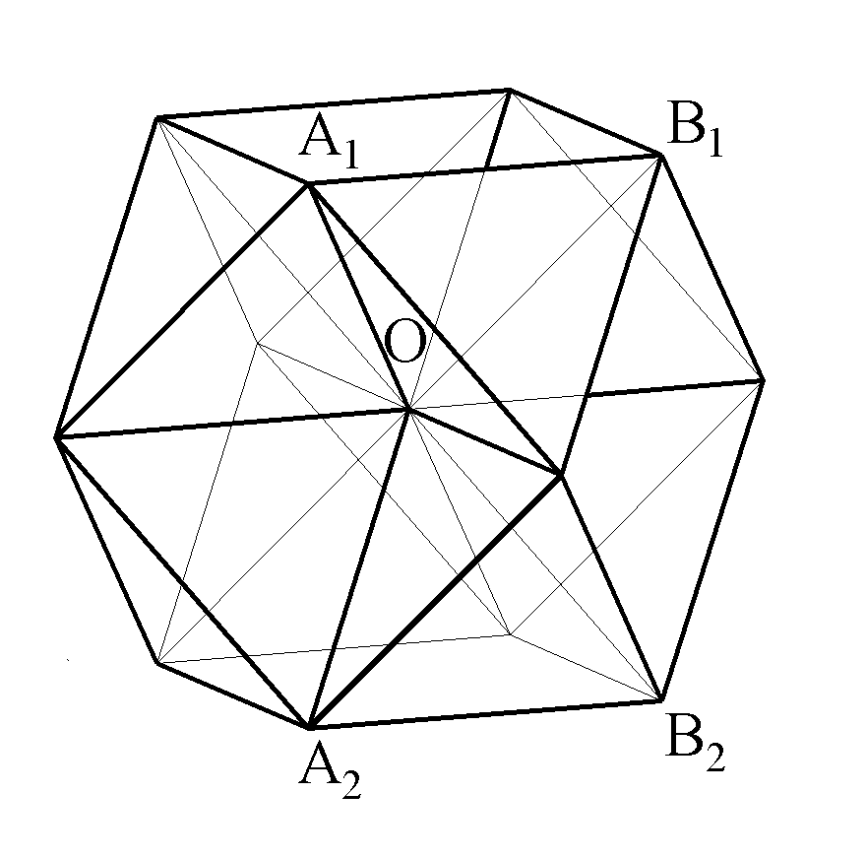

*Figure 1 Space filling by regular polyhedra*

1.4. Tables

All tables must be center aligned. Tables (e.g., Table 1) must be numbered consecutively from start to finish of the paper, ignoring sections and subsections. All tables must have a caption, center justified in 9 pt. Open Sans. Captions follow tables. Tables must appear as close to their point of reference as satisfactory formatting of the final document permits. Text in tables: Font: 9 pt, Open Sans. The source of the figures must be given, listed at the end of the paper.

|  |  |  |  |
| --- | --- | --- | --- |
| ***Group of students*** | ***September*** | ***December*** | ***May*** |
| **Architectural engineers** |  |  |  |
| Failed | 12,24 | - | - |
| Satisfactory | 10,90 | 12,60 | 11,46 |
| Fair | 13,23 | 15,31 | 15,78 |
| Good | 13,86 | 15,55 | 16,20 |
| Excellent | 17,58 | 18,95 | 19,68 |
| **Civil engineers** |  |  |  |
| Failed | 9,79 | - | - |
| Satisfactory | 9,38 | 11,42 | - |
| Fair | 11,80 | 14,04 | - |
| Good | 12,60 | 14,87 | - |
| Excellent | 14,00 | 16,00 | - |

*Table 1 The development of MCT results in the light of passmarks*

X. (LAST SECTION) CONCLUSIONS

The last section will be the Conclusions, where the authors summarize their results and initiate new projects. This is the text of the Conclusions. This is the text of the Conclusions. This is the text of the Conclusions. This is the text of the Conclusions. This is the text of the Conclusions. This is the text of the Conclusions. This is the text of the Conclusions. This is the text of the Conclusions. This is the text of the Conclusions. This is the text of the Conclusions. This is the text of the Conclusions.

**ACKNOWLEDGMENTS**

Acknowledgments should be included at the end of the document. The body of the section should follow the font and layout of the body of the paper. Please identify all appropriate funding sources by name and contract number in this section.

# REFERENCES

Please, use the official IEEE reference format after creating your reference list. References should be cited in the main text by Arabic numerals in square brackets, as [1] or [2], [3], [4]. All publications cited in the text should be presented in a list of references following the text of the manuscript, in the order in which they are cited, in 9 pt. Open Sans, as showed below [5], [6].

[1] A. Henseke and J. H. Breuste, “Climate-change sensitive residential areas and their adaptation capacities by urban green changes: Case study of linz, Austria,” *J Urban Plan Dev*, vol. 141, no. 3, 2015, doi: 10.1061/(ASCE)UP.1943-5444.0000262.

[2] N. Brazeau-Béliveau and G. Cloutier, “Citizen participation at the micro-community level: The case of the green alley projects in Quebec City,” *Cities*, vol. 112, May 2021, doi: 10.1016/j.cities.2020.103065.

[3] B. Rinkevich, “Augmenting coral adaptation to climate change via coral gardening (the nursery phase),” *J Environ Manage*, vol. 291, p. 112727, Aug. 2021, doi: 10.1016/j.jenvman.2021.112727.

[4] M. Midgley, E. Anderson, and E. Minor, “Vacant lot plant establishment techniques alter urban soil ecosystem services,” *Urban For Urban Green*, vol. 61, Jun. 2021, doi: 10.1016/j.ufug.2021.127096.

[5] J. Cravero, A. Feraille, P.-A. Versini, J.-F. Caron, I. Tchiguirinskaia, and O. Baverel, “Sustainable design of vegetated structures: Building freshness,” in *IOP Conference Series: Earth and Environmental Science*, 2019. doi: 10.1088/1755-1315/323/1/012021.

[6] T. E. Hauck, Stefanie Hennecke, and Stefan Körner, Eds., *Aneignung urbaner Freiräume : ein Diskurs über städtischen Raum*. Bielefeld: transcript Verlag, 2017. Accessed: May 02, 2025. [Online]. Available: <https://www.transcript-verlag.de/978-3-8376-3686-4/aneignung-urbaner-freiraeume/>

**LIST OF FIGURES**

Figure 1 Space filling by regular polyhedra (source: xyxyxy) 3

**LIST OF TABLES**

Table 1 The development of MCT results in the light of passmarks (source: xyxyxy) 3