Template for Authors of Ybl Journal of Built Environment

Fiona First¹, Simon Second² and Thomas Third³

¹Department of Mathematics, Szent István University, Budapest, Hungary
f.first@xx.yy.zz
²Institute of Civil Engineering, Szent István University, Budapest, Hungary
s.second@zzz.com
³Institute of Architecture, Szent István University, Budapest, Hungary
t.third@xx.yy.zz

Abstract: The abstract must not exceed 150 words in length in 10 pt. Times New Roman italics. The text must be fully justified.

Keywords: There may be up to five keywords (or short phrases) in 10 pt. Times New Roman italics.

1. Section headings are numbered in 11 pt. ARIAL, capital, Alignment: left. Do not hyphenate.

About the structure of the paper: all manuscript begins with an Introduction as section 1. The following sections and subsections contain the methods of the research, the new theories and investigations of the authors. The last section will be the Conclusions, where the authors summarize their results and initiate new projects.
Main-body text is to written as follows: Font: 11 pt, Times New Roman. Alignment: fully justified. Indent first line: 0.5 cm.
This is the main-body of the text. This is the main-body of the text. This is the main-body of the text. This is the main-body of the text. This is the main-body of the text. This is the main-body of the text. This is the main-body of the text. This is the main-body of the text. This is the main-body of the text. This is the main-body of the text. This is the main-body of the text. This is the main-body of the text. This is the main-body of the text. This is the main-body of the text. This is the main-body of the text. This is the main-body of the text. This is the main-body of the text. This is the main-body of the text. This is the main-body of the text. This is the main-body of the text. This is the main-body of the text.
This is the main-body of the text. This is the main-body of the text. This is the main-body of the text. This is the main-body of the text. This is the main-body of the text. This is the main-body of the text. This is the main-body of the text. This is the main-body of the text. This is the main-body of the text. This is the main-body of the text. This is the main-body of the text. This is the main-body of the text. This is the main-body of the text. This is the main-body of the text. This is the main-body of the text. This is the main-body of the text. This is the main-body of the text. This is the main-body of the text. This is the main-body of the text. This is the main-body of the text. This is the main-body of the text.

1.1. Sub-section headings: font: 11 pt. ARIAL, bold, italic, justified: left. Use sentence case in the headings. Do not hyphenate.

This is the main-body of the text. This is the main-body of the text. This is the main-body of the text. This is the main-body of the text. This is the main-body of the text. This is the main-body of the text. This is the main-body of the text. This is the main-body of the text. This is the main-body of the text. This is the main-body of the text. This is the main-body of the text. This is the main-body of the text. This is the main-body of the text. This is the main-body of the text. This is the main-body of the text. This is the main-body of the text. This is the main-body of the text. This is the main-body of the text. This is the main-body of the text. This is the main-body of the text. This is the main-body of the text.
This is the main-body of the text. This is the main-body of the text. This is the main-body of the text. This is the main-body of the text. This is the main-body of the text. This is the main-body of the text. This is the main-body of the text. This is the main-body of the text. This is the main-body of the text. This is the main-body of the text. This is the main-body of the text. This is the main-body of the text. This is the main-body of the text. This is the main-body of the text. This is the main-body of the text. This is the main-body of the text. This is the main-body of the text. This is the main-body of the text. This is the main-body of the text. This is the main-body of the text. This is the main-body of the text.
This is the main-body of the text. This is the main-body of the text. This is the main-body of the text. This is the main-body of the text. This is the main-body of the text. This is the main-body of the text. This is the main-body of the text. This is the main-body of the text. This is the main-body of the text. This is the main-body of the text. This is the main-body of the text. This is the main-body of the text. This is the main-body of the text. This is the main-body of the text. This is the main-body of the text.

1.2. Equation

Position of equations: Indent: left 1 cm. Tabs: right 0.75 cm. If the equation is so long that less than 1 cm will be left between the end of the equation and the equation number, then it may run on to the next line. Number equations consecutively, not section-wise. Place the numbers in parentheses at the right-hand margin, level with the last line of the equation. Refer to equations in the text as e.g. Eq. (1). Use MS Word Equation Editor or MathType for in-text and display notation wherever possible. The equation is followed by the explanations of the new notions. E.g.:

, (1)
where:

a – is the quadratic coefficient;
b – is the linear coefficient;
c – is the constant term.

1.3. Figures

All inserts, figures, diagrams and photographs must be centre-aligned and clear. The resolution of the inserted pictures is 300 dpi and the source image should be sent also separately. The size of the figures can not exceed 12cm in width and 18cm in height. Figures (eg, Figure 1) must be numbered consecutively from start to finish of the paper, ignoring sections and subsections. All figures must have a caption, centre-justified in 11 pt. Times New Roman. Captions follow figures. Figures must appear as close to their point of reference as satisfactory formatting of the final document permits.

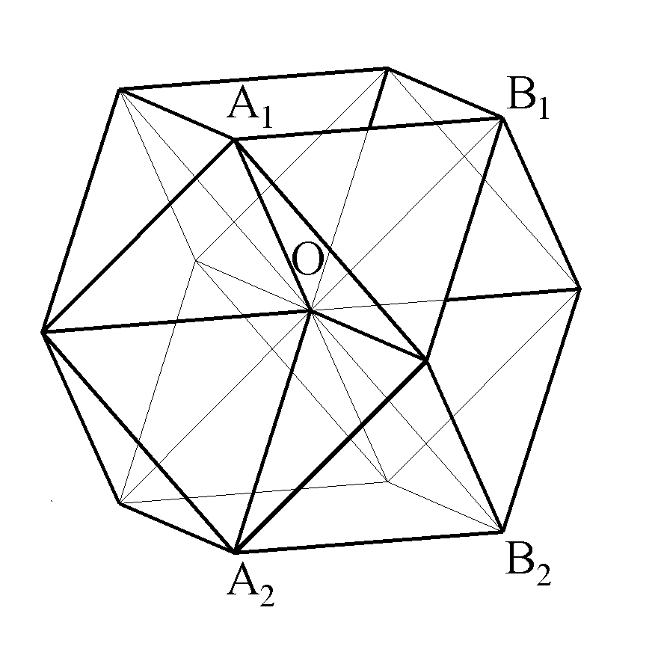
Figure 2 Space filling by regular polyhedra

1.4. Tables

All tables must be centre-aligned. The size of the tables can not exceed 10cm in width and 15cm in height. Tables (eg, Table 1) must be numbered consecutively from start to finish of the paper, ignoring sections and subsections. All tables must have a caption, centre-justified in 11 pt. Times New Roman. Captions follow tables. Tables must appear as close to their point of reference as satisfactory formatting of the final document permits.

Group of students | September | December | May
Architectural engineers
Failed | 12,24 | - | -
Satisfactory | 10,90 | 12,60 | 11,46
Fair | 13,23 | 15,31 | 15,78
Good | 13,86 | 15,55 | 16,20
Excellent | 17,58 | 18,95 | 19,68
Civil engineers
Failed | 9,79 | - | -
Satisfactory | 9,38 | 11,42 | -
Fair | 11,80 | 14,04 | -
Good | 12,60 | 14,87 | -
Excellent | 14,00 | 16,00 | -

Table 2 The development of MCT results in the light of passmarks

1.5. References

References should be cited in the main text by arabic numerals in square brackets, as [1] or [2, 5, 11]. All publications cited in the text should be presented in a list of references following the text of the manuscript, in the order in which they are cited, in 10 pt. Times New Roman, as showed below.

Acknowledgments

Acknowledgments should be included at the end of the document. The body of the section should follow the font and layout of the body of the paper. Please identify all appropriate funding sources by name and contract number in this section.

references

- Grünbaum, B., Shephard G.C., Tilings and Patterns, New York: W.H: Freeman, 1987, pp. 537.
- Bölcskei, A., Gál-Kállay, Sz., Kovács, A. Zs., Sörös, Cs., Development of Spatial Abilities of Architect and Civil Engineer Students in the Light of the Mental Cutting Test, Journal for Geometry and Graphics, Volume 16 (2012), No 1, 97–109.
- http://www.asz.ymmf.hu/geometria/

